University of Calcutta

A Project Report on

ADVANCED ENCRYPTION STANDARD (AES) IMPLEMENTATION

A project submitted as part of fulfillment of B.Sc(Hons.) in Computer Science,
Semester -VI, 2021 in the department of Computer Science, T.H.K Jain College

Under the Supervision of Puja Paul
Department of Computer Science
T.H.K Jain College

Submitted by Name: Nikita Dubey
Roll No:183235-11-0015
Registration No:235-1211-0848-18
Name: Mushkan Soni Roll No:183235-11-0018
Registration No:235-1211-0852-18
Name: Priti Sah Roll No:183235-11-0012
Registration No:235-1211-0848-18



CERTIFICATE

This is to certify that the project entitled “PROJECT NAME” submitted for the requirements of 6thSemester of B.Sc in Computer Science (Honours), University Of Calcutta; has been carried out by Name: Nikita Dubey (Roll No: - 183235-11-0015 and Registration No:(235-1211-0848-18),Name: Mushkan Soni (Roll No: - 183235-11- 0018 and Registration No:(235-1211-0852-18) and Name: Priti Sah (Roll No: - 183235-11-0012 and Registration No:(235-1211-08-18) under the supervision of P r o f . Puja Paul, T.H.K JAIN COLLEGE , University of Calcutta.

-------------------------------
Prof. Puja Paul
Project Supervisor
Dept. of Computer Science
T.H.K Jain College

Prof. Rituparna Kundu Department In-Charge Dept. of Computer Science
T.H.K Jain College

External Examiner

ACKNOWLEDGEMENT

We wish to express our profound sense of gratitude of our project supervisor Prof. Teacher Name, T.H.K Jain College, University of Calcutta for his/her support, inspiration and guidance. He/She has showed us different ways to approach a problem. We have also learned from him/her that an approach needs to be persistent to accomplish our goal. We are immensely grateful to him/her for giving his/her valuable time and constant advice for discussing various ideas related to our project work. It is being precious learning experience for us to work under tutelage.
We are also thankful to our department; Department of Computer Science, T.H.K Jain College, University of Calcutta; for providing us with the required resources for working on this project.
Lastly, we like to express our heartiest gratitude to our parents, seniors and our friends and to all who have directly or indirectly extended their valuable guidance and advice during the preparation of this project; which will give us the continuous flow of inspiration to complete the project.

Date: -
Name(s):

1.Nikita Dubey
2.Mushkan Soni
3.Priti Sah

CONTENTS

2. Introduction
- Abstract

  - Domain Description
  - Motivation
  - Scope of work

- Background/Review of related work
- Methodology
  - Problem Formulation
  - Algorithm Description
  - Other design descriptions

- Implementation
- Results and Discussion
- Conclusion

- References

ABSTRACT

Encryption is the most effective way to achieve data security. The Advanced Encryption Standard (AES), also known as Rijndael (its original name), is a specification for the encryption of electronic data established by the U.S. National Institute of Standards and Technology (NIST) in 2001.
The aim of the project is to achieve an efficient Python implementation of 128-bit block and 128-bit key AES cryptosystem. An Optimized Python code is developed for the implementation of both 128-bit data encryption and decryption process & description is verified using Visual Studio Code.

Domain Description
1.1.1 WHAT IS CRYPTOGRAPHY?
To enhance the security of the data, code language for writing messages were used. The branch of mathematics that investigates the code languages and methods is called cryptology. Cryptology consists of two streams namely cryptography and cryptanalysis. Cryptography is a science of coding message secretly while cryptanalysis is a science of breaking codes.

CRYPTOLOGY

CRYPTOGRAPHY CRYPTANALYSIS

Our project is concerned with cryptography. Cryptography is a science of using mathematics to encrypt and decrypt data. Cryptography enables to store sensitive information or transmit it across insecure networks so that it cannot be read by anyone except the intended recipient.
AES comprises three block ciphers, AES-128, AES-192 and AES-256. Each cipher encrypts and decrypts data in blocks of 128 bits using cryptographic keys of 128-,192- and 256-bits, respectively. Symmetric or secret-key ciphers use the same key for encrypting and decrypting, so both the sender and the receiver must know and use the same secret key. All key lengths are deemed sufficient to protect classified information up to the "Secret" level with "Top Secret" information requiring either 192- or 256-bit key lengths.

Symmetric or Private key
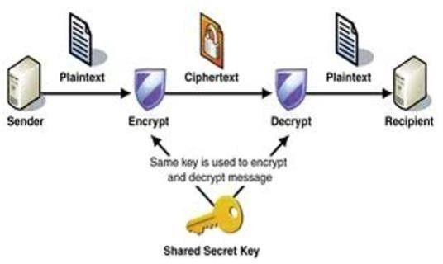
key cryptography systems use the same key for both to encrypt the plain text and to decrypt the cipher text. Symmetric key systems have the advantage of being simple and fast. However, the important factor to be considered is that the parties involved must exchange the key in a secured way.

Fig -1: Secret key scheme

Public Key
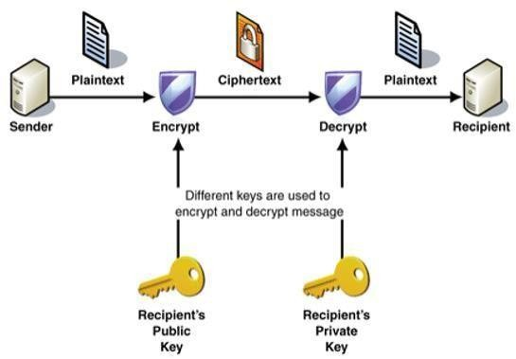
In comparison to symmetric key, public key cryptography systems use different keys to encrypt to plaintext and to decrypt the cipher text. In comparison to symmetric key, public key cryptography systems use different keys to encrypt to plaintext and to decrypt the cipher text.

Fig -2: Public key scheme

Public key uses 2 different keys – a public key for encryption and a private key for decryption. Using this encryption system, the public key can be distributed in a non-secure way. The private key is never transmitted and is only available at the recipient’s side. As the keys are different, the decryption of the cipher text computationally is assumed to be not feasible without the private key.

HOW DOES CRYPTOGRAPHY WORK?

A cryptographic algorithm, or cipher, is a mathematical function used in the encryption and decryption process. A cryptographic algorithm works in combination with a key—a word, number, or phrase—to encrypt the plaintext. The same plaintext encrypts to different ciphertext with different keys.
The security of encrypted data is entirely dependent on two things: the strength of the cryptographic algorithm and the secrecy of the key.

Motivation

In today's electronic age, the importance of digital cryptography in securing electronic data transactions is unquestionable. Every day, users electronically generate and communicate a large volume of information with others. This information includes medical, financial and legal files; automatic and Internet banking; phone conversations; pay-per-view television; and other e-commerce transactions. To meet these requirements, Advanced Encryption Standard (AES) for the encryption of electronic data can be used.
Here we are going to achieve an efficient Python implementation of 128bit block and 128-bit key AES cryptosystem

What are the differences between DES and AES encryption?

 | DES | AES
Developed | 1977 | 2000
Key Length | 56 bits | 128, 192, or 256 bits
Cipher Type | Symmetric block cipher | Symmetric block cipher
Block Size | 64 bits | 128 bits
Security | Proven inadequate | Considered secure

Scope Of the Work

The scope of work for this project will cover the development of cryptography. This project will be focused on the process of encryption of a text message. In future we can further build our project to a GUI based application available on several platforms like windows, android etc.

BACKGROUND AND REVIEW OF RELATED WORK

Encryption is the most effective way to achieve data security and it is widely used in various types of encryptions of text, audio, image, etc.
It has several advantages: This robust security algorithm may be implemented in both hardware and software.
It is resilient against hacking attempts, Due to its higher-length key sizes (128, 192, and 256 bits). In our project we have used key-size of 128-bits It is an open-source solution.

METHODOLOGY

1.Problem Formulation:

In our code we are taking an user input of a text message and performed various steps involved in the process of encryption decryption and output the ciphered text .
Steps involved in aes encryption are:-
ShiftRows
SubByte
AddRoundKey
Mix column

Introduction to the Advanced Encryption Standard

The Advanced Encryption Standard (AES), also known as Rijndael (its original name), is a specification for the encryption of electronic data established by the U.S. National Institute of Standards and Technology (NIST) in 2001.AES is based on the Rijndael cipher developed by two Belgian cryptographers, Joan Daemen and Vincent Rijmen, who submitted a proposal to NIST during the AES selection process. Rijndael is a family of ciphers with different key and block sizes. For AES, NIST selected three members of the Rijndael family, each with a block size of 128 bits, but three different key lengths: 128, 192 and 256 bits. AES has been adopted by the U.S. government and is now used worldwide. It supersedes the Data Encryption Standard (DES), which was published in 1977. The algorithm described by AES is a symmetric-key algorithm, meaning the same key is used for both encrypting and decrypting the data. In the United States, AES was announced by the NIST as U.S. FIPS PUB 197 (FIPS 197) on November 26, 2001.This announcement followed a five-year standardization process in which fifteen competing designs were presented and evaluated, before the Rijndael cipher was selected as the most suitable.AES became effective as a federal government standard on May 26, 2002 after approval by the Secretary of Commerce.AES is included in the ISO/IEC 18033-3 standard.
AES is available in many different encryption packages, and is the first publicly accessible and open cipher approved by the National Security Agency (NSA) for top secret information when used in an NSA approved cryptographic module. The name Rijndael is a play on the names of the two inventors (Joan Daemen and Vincent Rijmen). It is also a combination of the Dutch name for the Rhine River and a dale.

Description of the cipher

AES is based on a design principle known as a substitution-permutation network, combination of both substitution and permutation, and is fast in both software and hardware. AES is a variant of Rijndael which has a fixed block size of 128 bits, and a key size of 128, 192, or 256 bits. By contrast, the Rijndael specification specified with block and key sizes that may be any multiple of 32 bits, both with a minimum of 128 and a maximum of 256 bits. AES operates on a 4×4 column-major order matrix of bytes, termed the state, although some versions of Rijndael have a larger block size and have additional columns in the state. Most AES calculations are done in a special finite field. For instance, if you have 16 bytes, b0, b1... b15, these bytes
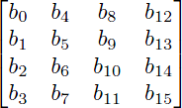
are represented as this matrix:

The key size used for an AES cipher specifies the number of repetitions of transformation rounds that convert the input, called the plaintext, into the final output, called the cipher text. The number of cycles of repetition is as follows:
- 10 cycles of repetition for 128-bit keys.
- 12 cycles of repetition for 192-bit keys.
- 14 cycles of repetition for 256-bit keys.
Each round consists of several processing steps, each containing four similar but different stages, including one that depends on the encryption key itself. A set of reverse rounds are applied to transform cipher text back into the original plaintext using the same encryption key.

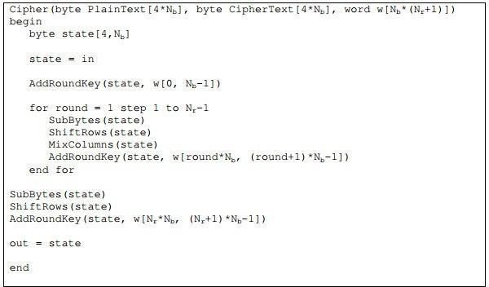
Fig1 Cipher description

AES Algorithm Structure

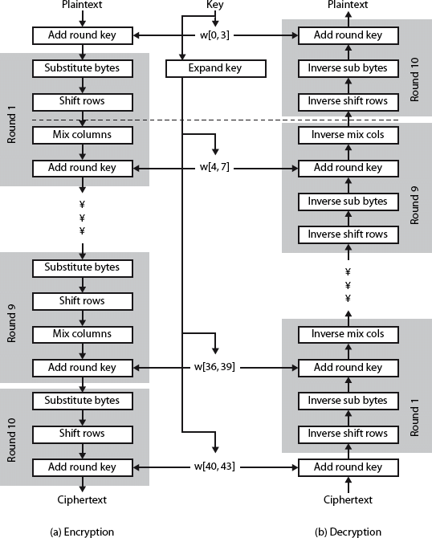

Description of the algorithm

1.KeyExpansions
Round keys are derived from the cipher key using Rijndael’s key schedule. AES requires a separate 128-bit round key block for each round plus one more.
2.InitialRound

(a) AddRoundKey—each byte of the state is combined with a block of the round key using bitwise xor.

3.Rounds

(a)SubBytes—a non-linear substitution step where each byte is replaced with another according to a lookup table.

(b)ShiftRows—a transposition step where the last three rows of the state are shifted cyclically a certain number of steps.

(c)MixColumns—a mixing operation which operates on the columns of the state, combining the four bytes in each column.

(d)AddRoundKey

4.Final Round (no MixColumns)

(a)SubBytes
(b)ShiftRows
(c)AddRoundKey

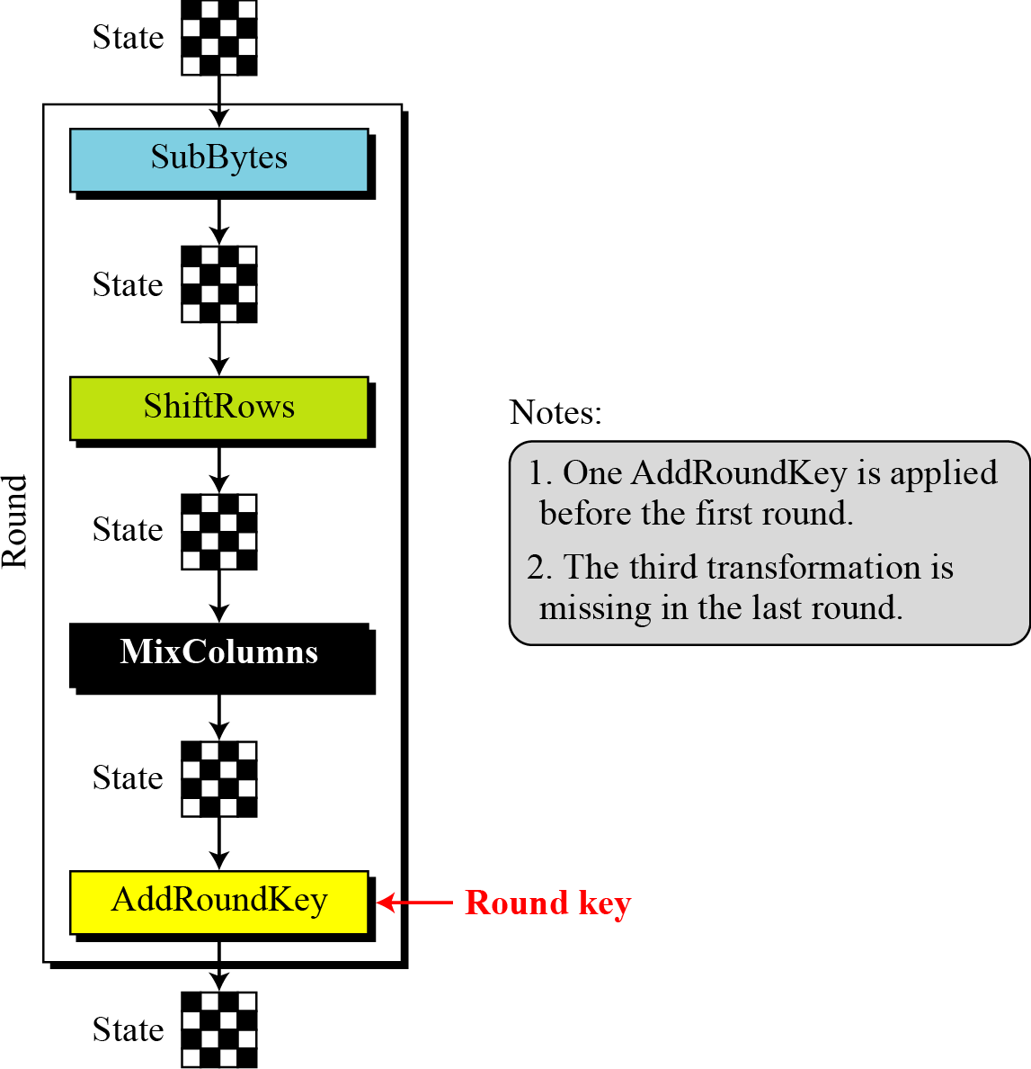

Fig 2 Operations involved in AES algorithm

The Rijndael Key Schedule

TheKeyScheduleisresponsibleforexpandingashortkeyintoalargerkey,whosepartsareusedduringthe different iterations. Each key size is expanded to a different size:
  - An 128 bitkey is expanded to an 176bytekey.
  - An 192 bitkey is expanded to an 208bytekey.
  - An 256 bitkey is expanded to an 240bytekey.
There is a relation between the cipher key size, the number of rounds and the Expanded Key size. For an 128- bitkey, there is one initial AddRoundKey operation plus thereare10rounds andeachroundneedsanew16 byte key, therefore we require 10+1Round Keys of 16byte, which equals 176byte. The same logic can be applied to the two other cipher key sizes. The general formula is that:
ExpandedKeySize = (nbrRounds+1) * BlockSize

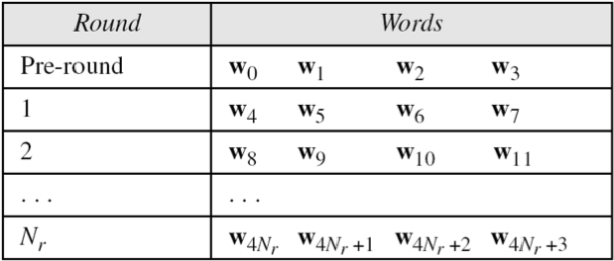
Fig 3 AES Key Scheduling

This step takes 128-bits (16-bytes) key and expands into array of 44 32-bit words.

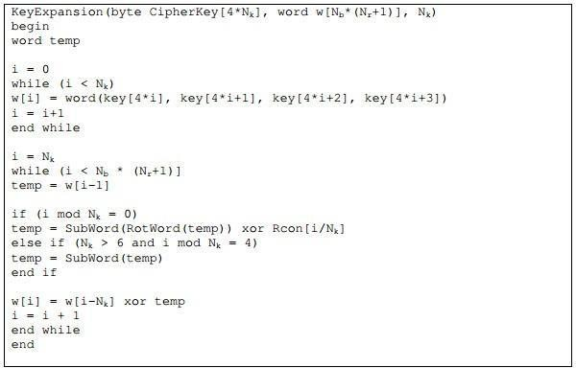

AES operations

1.The SubBytes operation
The SubBytes operation is a non-linear byte substitution, operating on each byte of the state independently. The substitution table (S- Box) is invertible and is constructed by the composition of two transformations:
1.Take the multiplicative inverse in Rijndael's finite field

2.Apply an affine transformation which is documented in the Rijndael documentation. Since the S-Box is independent of any input, pre-calculated forms are used. Each byte of the state is then substituted by the value in the S-Box whose index corresponds to the value in the state
b (i,j) = SBox[a(i,j)]

The inverse of SubBytes is the same operation, using the inversed S-Box, which is also precalculated

.

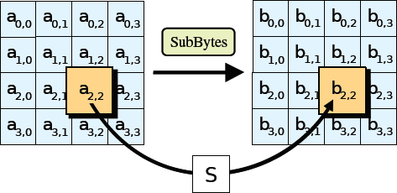

Fig4 SubBytes step

In the SubBytes step, each byte in the state is replaced with its entry in a fixed 8-bit lookup table, S; b(i,j) = S(i,j)

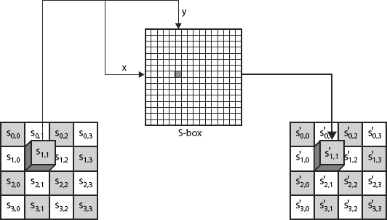

Fig 5 S-box implementation on the state matrix

SubBytes Table

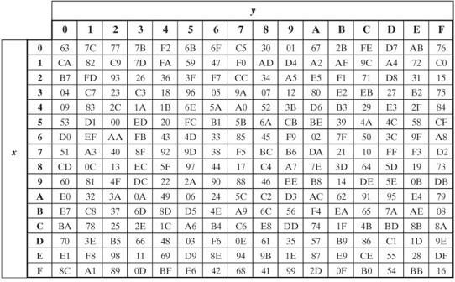
Fig 6 SubBytes Table

InvSubBytes Table
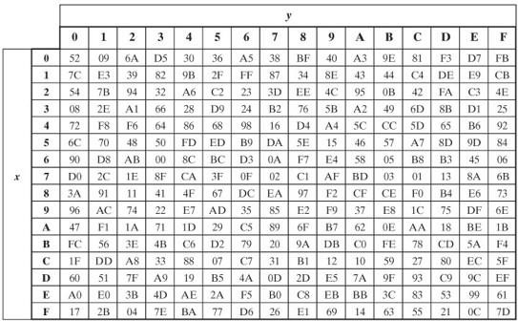
Fig 7 InvSubBytes Table

Sample SubByte Transformation:

The SubBytes and InvSubBytes transformations are inverses of each other.

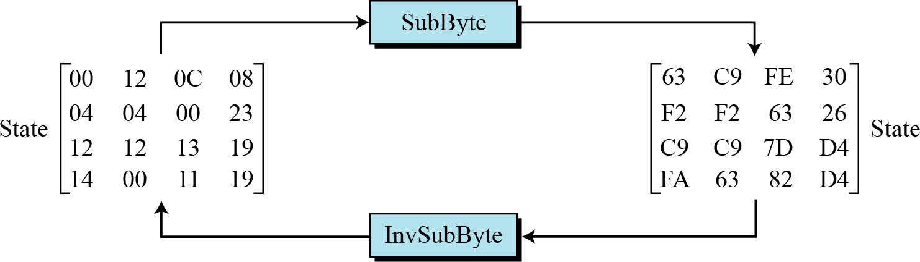

Fig 8 An example of SubBytes and InvSubBytes transformations

- The ShiftRow operation:
In this operation, each row of the state is cyclically shifted to the left, depending on the row index.
  - The 1st row is shifted 0 positions to the left.
  - The 2nd row is shifted 1 position to the left.
  - The 3rd row is shifted 2 positions to the left.
  - The 4th row is shifted 3 positions to the left.
The inverse of Shift Row is the same cyclically shift but to the right. It is needed later for decoding.

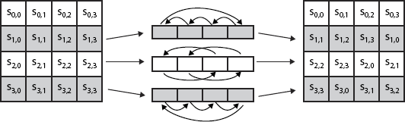

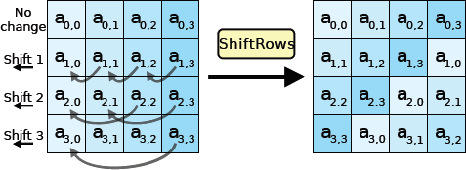
Fig 9 Shift Rows Scheme

In the ShiftRows step, bytes in each row of the state are shifted cyclically to the left. The number of places each byte is shifted differs for each row.

ShiftRows and InvShiftRows:

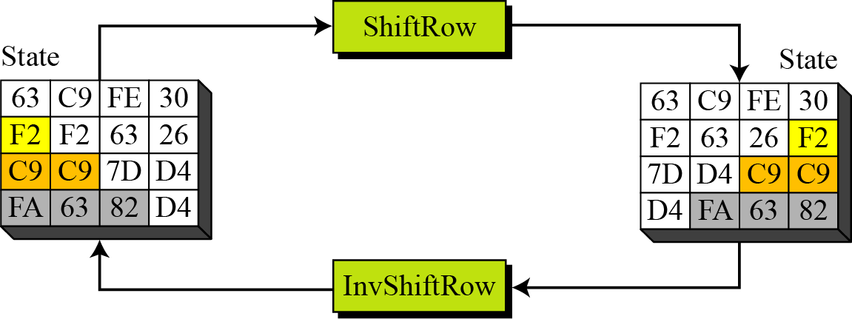

Fig 10 An example of ShiftRows and InvShiftRows

- The MixColumn operation

In the MixColumns step, the four bytes of each column of the state are combined using an invertible linear transformation. The MixColumns function takes four bytes as input and outputs four bytes, where each input byte affects all four output bytes. Together with ShiftRows, MixColumns provides diffusion in the cipher.
During this operation, each column is transformed using a fixed matrix (matrix multiplied by column gives new value of column in the state):
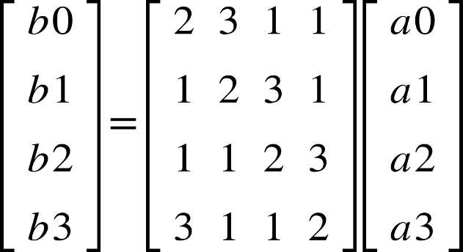

This can also be seen as the following:

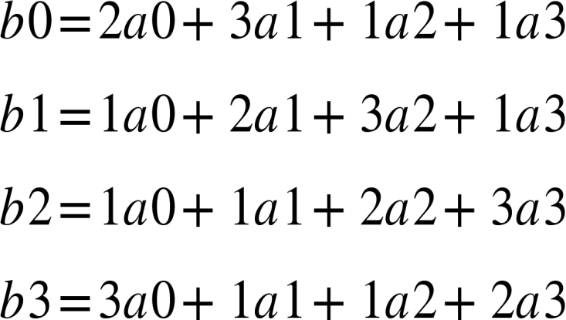

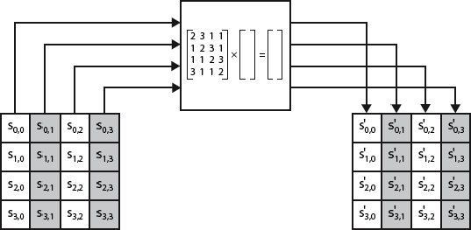

Fig 11 MixColumns Scheme

The MixColumns operation has the following inverse (numbers are decimal):

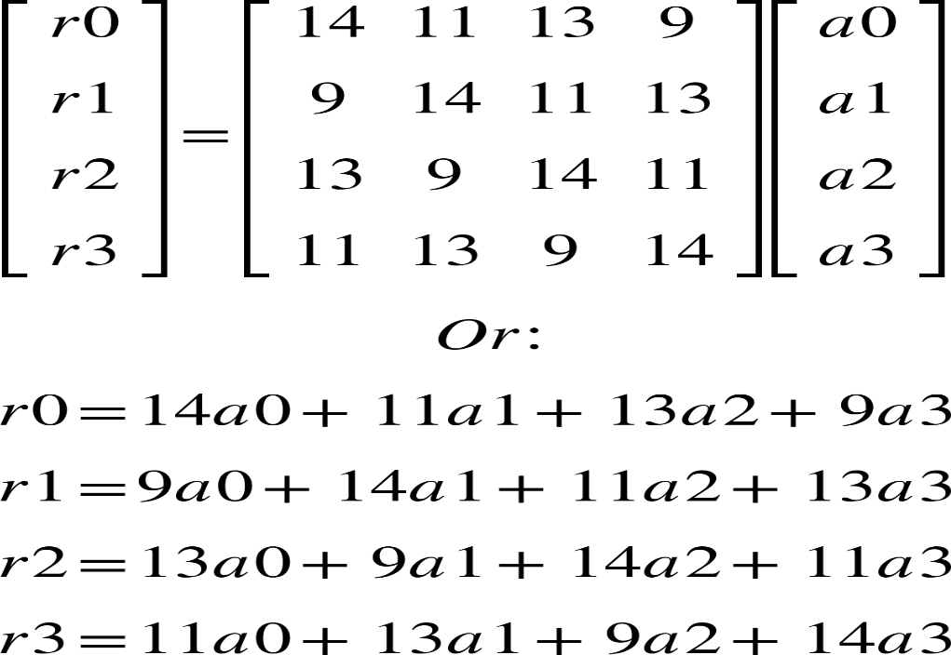

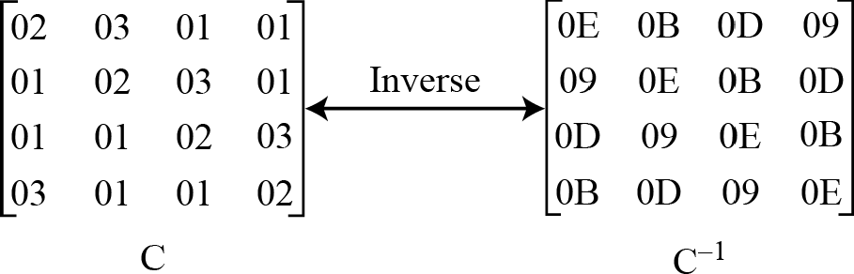

Fig 12 Mix Column and Inv Mix Column

87 | F2 | 4D | 97
6E | 4C | 90 | EC
46 | E7 | 4A | C3
A6 | 8C | D8 | 95

47 | 40 | A3 | 4C
37 | D4 | 70 | 9F
94 | E4 | 3A | 42
ED | A5 | A6 | BC

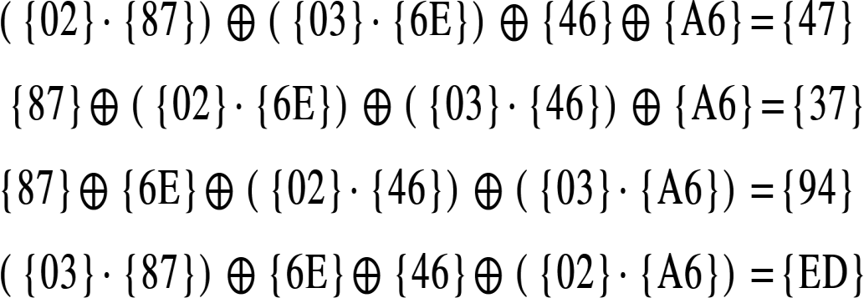

Fig 13 An example of AES mix columns operation

4.The AddRoundKey operation

In this operation, a Round Key is applied to the state by a simple bitwise XOR. The Round Key is derived from the Cipher Key by the means of the key schedule. The Round Key length is equal to the block key length (=16 bytes).

In the AddRoundKey step, the subkey is combined with the state. For each round, a subkey is derived from the main key using Rijndael’s key schedule; each subkey is the same size as the state. The subkey is added by combining each byte of the state with the corresponding byte of the subkey using bitwise XOR.

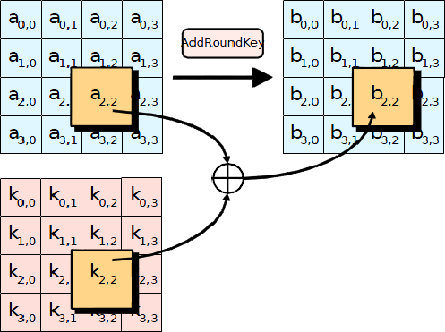

In the AddRoundKey step, each byte of the state is combined with a byte of the round subkey using the XOR operation.

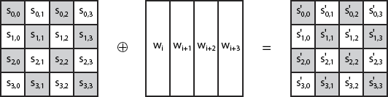

Fig 14 AddRoundKey Scheme

Other Design Descriptions

Data Flow Diagram 0-Level of AES Algorithm: -

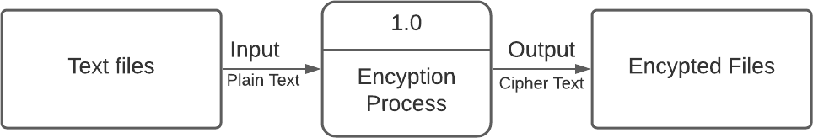

Data Flow Diagram 1-Level of AES Algorithm: -

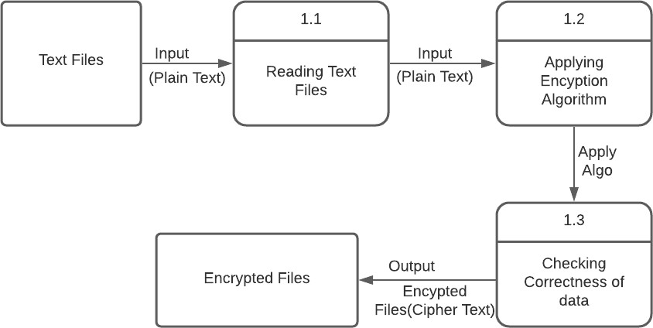

Implementation
Source Code:-

#Substitution Box
s_box=[['63','7c','77','7b','f2','6b','6f','c5','30','01','67','2b','fe','d7','ab','76'],
['ca','82','c9','7d','fa','59','47','f0','ad','d4','a2','af','9c','a4','72','c0'],
['b7','fd','93','26','36','3f','f7','cc','34','a5','e5','f1','71','d8','31','15'],
['04','c7','23','c3','18','96','05','9a','07','12','80','e2','eb','27','b2','75'],
['09','83','2c','1a','1b','6e','5a','a0','52','3b','d6','b3','29','e3','2f','84'],
['53','d1','00','ed','20','fc','b1','5b','6a','cb','be','39','4a','4c','58','cf'],
['d0','ef','aa','fb','43','4d','33','85','45','f9','02','7f','50','3c','9f','a8'],
['51','a3','40','8f','92','9d','38','f5','bc','b6','da','21','10','ff','f3','d2'],
['cd','0c','13','ec','5f','97','44','17','c4','a7','7e','3d','64','5d','19','73'],
['60','81','4f','dc','22','2a','90','88','46','ee','b8','14','de','5e','0b','db'],
['e0','32','3a','0a','49','06','24','5c','c2','d3','ac','62','91','95','e4','79'],
['e7','c8','37','6d','8d','d5','4e','a9','6c','56','f4','ea','65','7a','ae','08'],
['e7','c8','37','6d','8d','d5','4e','a9','6c','56','f4','ea','65','7a','ae','08'],
['70','3e','b5','66','48','03','f6','0e','61','35','57','b9','86','c1','1d','9e'],
['e1','f8','98','11','69','d9','8e','94','9b','1e','87','e9','ce','55','28','df'],
['8c','a1','89','0d','bf','e6','42','68','41','99','2d','0f','b0','54','bb','16']]
# Substitution Box Ends

#To Print State In Matrix Form
def print(State):
print()
for i in range(4):
for j in range(4):
print(State[i][j]," ",end="")
print()
print()

#AddRoundKey Function
def AddRoundKey (State,w,rnd,Nb):
for c in range(Nb):
State[0][c]=hex(int(State[0][c],16)^int(w[rnd*Nb] [c],16)).lstrip('0x').zfill(2)
State[1][c]=hex(int(State[1][c],16)^int(w[rnd*Nb+1][c],16)).lstrip('0x').zfill(2)
State[2][c]=hex(int(State[2][c],16)^int(w[rnd*Nb+2][c],16)).lstrip('0x').zfill(2)
State[3][c]=hex(int(State[3][c],16)^int(w[rnd*Nb+3][c],16)).lstrip('0x').zfill(2)

#Shift Row Operation
def ShiftRows(State):
for i in range(0,4):
State[i]=State[i][i:]+State[i][:i]

#Mix Column Operation
def MixColumns(State):
#Galois Field Multiplication Table Of 2
mul2=[['00','02','04','06','08','0a','0c','0e','10','12','14','16','18','1a','1c','1e'],
['20','22','24','26','28','2a','2c','2e','30','32','34','36','38','3a','3c','3e'],
['40','42','44','46','48','4a','4c','4e','50','52','54','56','58','5a','5c','5e'],
['60','62','64','66','68','6a','6c','6e','70','72','74','76','78','7a','7c','7e'],
['80','82','84','86','88','8a','8c','8e','90','92','94','96','98','9a','9c','9e'],
['a0','a2','a4','a6','a8','aa','ac','ae','b0','b2','b4','b6','b8','ba','bc','be'],
['c0','c2','c4','c6','c8','ca','cc','ce','d0','d2','d4','d6','d8','da','dc','de'],
['e0','e2','e4','e6','e8','ea','ec','ee','f0','f2','f4','f6','f8','fa','fc','fe'],
['1b','19','1f','1d','13','11','17','15','0b','09','0f','0d','03','01','07','05'],
['3b','39','3f','3d','33','31','37','35','2b','29','2f','2d','23','21','27','25'],
['5b','59','5f','5d','53','51','57','55','4b','49','4f','4d','43','41','47','45'],
['7b','79','7f','7d','73','71','77','75','6b','69','6f','6d','63','61','67','65'],
['9b','99','9f','9d','93','91','97','95','8b','89','8f','8d','83','81','87','85'],
['bb','b9','bf','bd','b3','b1','b7','b5','ab','a9','af','ad','a3','a1','a7','a5'],
['db','d9','df','dd','d3','d1','d7','d5','cb','c9','cf','cd','c3','c1','c7','c5'],
['fb','f9','ff','fd','f3','f1','f7','f5','eb','e9','ef','ed','e3','e1','e7','e5']]

#Galois Field Multiplication Table Of 3
mul3=[['00','03','06','05','0c','0f','0a','09','18','1b','1e','1d','14','17','12','11'],
['30','33','36','35','3c','3f','3a','39','28','2b','2e','2d','24','27','22','21'],
['60','63','66','65','6c','6f','6a','69','78','7b','7e','7d','74','77','72','71'],
['50','53','56','55','5c','5f','5a','59','48','4b','4e','4d','44','47','42','41'],
['c0','c3','c6','c5','cc','cf','ca','c9','d8','db','de','dd','d4','d7','d2','d1'],
['f0','f3','f6','f5','fc','ff','fa','f9','e8','eb','ee','ed','e4','e7','e2','e1'],
['a0','a3','a6','a5','ac','af','aa','a9','b8','bb','be','bd','b4','b7','b2','b1'],
['90','93','96','95','9c','9f','9a','99','88','8b','8e','8d','84','87','82','81'],
['9b','98','9d','9e','97','94','91','92','83','80','85','86','8f','8c','89','8a'],
['ab','a8','ad','ae','a7','a4','a1','a2','b3','b0','b5','b6','bf','bc','b9','ba'],
['fb','f8','fd','fe','f7','f4','f1','f2','e3','e0','e5','e6','ef','ec','e9','ea'],
['cb','c8','cd','ce','c7','c4','c1','c2','d3','d0','d5','d6','df','dc','d9','da'],
['5b','58','5d','5e','57','54','51','52','43','40','45','46','4f','4c','49','4a'],
['6b','68','6d','6e','67','64','61','62','73','70','75','76','7f','7c','79','7a'],
['3b','38','3d','3e','37','34','31','32','23','20','25','26','2f','2c','29','2a'],
['0b','08','0d','0e','07','04','01','02','13','10','15','16','1f','1c','19','1a']]
for i in range(4):
S0i=int(State[0][i],16)
S1i=int(State[1][i],16)
S2i=int(State[2][i],16)
S3i=int(State[3][i],16)
S0=hex((int(mul2[int(State[0][i][0],16)][int(State[0][i][1],16)],16))^(int(mul3[int(State[1][i][0],16)][int(State[1][i][1],16)],16))^S2i^S3i).lstrip('0x').zfill(2)
S1=hex(S0i^(int(mul2[int(State[1][i][0],16)][int(State[1][i][1],16)],16))^(int(mul3[int(State[2][i][0],16)][int(State[2][i][1],16)],16))^S3i).lstrip('0x').zfill(2)
S2=hex(S0i^S1i^(int(mul2[int(State[2][i][0],16)][int(State[2][i][1],16)],16))^(int(mul3[int(State[3][i][0],16)][int(State[3][i][1],16)],16))).lstrip('0x').zfill(2)
S3=hex((int(mul3[int(State[0][i][0],16)][int(State[0][i][1],16)],16))^S1i^S2i^(int(mul2[int(State[3][i][0],16)][int(State[3][i][1],16)],16))).lstrip('0x').zfill(2)
State[0][i]=S0
State[1][i]=S1
State[2][i]=S2
State[3][i]=S3

#SubByte Operation
def SubBytes(a):
#To Substitue
for i in range(4):
for j in range(4):
x=int(a[i][j][0],16)
y=int(a[i][j][1],16)
a[i][j]=s_box[x][y]
return a

#Function To Convert Input Message Into Hexadecimal Equivalent
def state(txt):
State=[]
ind=0
for l in range(4): # A for loop for row entries
a =[]
for m in range(4): # A for loop for column entries
a.append(hex(ord(txt[ind])).lstrip('0x').zfill(2))
ind+=1
State.append(a)
State = [[State[j][i] for j in range(len(State))] for i in range(len(State[0]))] #Converting Rows To Columns
return State

#Function To XOR Two Hexadecimal Lists
def xor(a,b):
li=[hex(int(i,16)^int(j,16)).lstrip('0x').zfill(2) for i,j in zip(a,b)]
return li

#Round Constant For Key Expansion
def Rcon(i):
r_c=['02','00','00','00']
n=r_c.copy()
if i<9:
n[0]=hex(int(n[0])**(i-1)).lstrip('0x').zfill(2)
elif i==9:
n[0]=hex(27).lstrip('0x')
else:
n[0]=hex(36).lstrip('0x')
return n

#RotWord Operation Of Key Expansion
def RotWord(temp):
for i in range(4):
temp[i]=temp[i][1:]+temp[i][:1]
return temp

#SubWord Operation Of Key Expansion
def SubWord(temp):
#To Substitue
for i in range(4):
x=int(temp[i][0],16)
y=int(temp[i][1],16)
temp[i]=s_box[x][y]
return temp

#KeyExpansion Function
def KeyExpansion(key,Nk,Nb,Nr):
i=0
w=[]
while(i<Nk):
w.append([hex(ord(key[4*i])).lstrip('0x').zfill(2),hex(ord(key[4*i+1])).lstrip('0x').zfill(2),hex(ord(key[4*i+2])).lstrip('0x').zfill(2),hex(ord(key[4*i+3])).lstrip('0x').zfill(2)])
i+=1
i=Nk
w = [[w[j][i] for j in range(len(w))] for i in range(len(w[0]))] #Converting Rows To Columns
while(i<Nb*(Nr+1)):
temp=w[i-1].copy()
if i%Nk==0:
temp=xor(SubWord(RotWord(temp)),Rcon(i//Nk))
w.append(xor(w[i-Nk],temp))
i+=1
return w
#Cipher Function To Create Cipher Text
def Cipher(in_msg,key,Nb,Nr,Nk):
State=state(in_msg)
rnd=0
print()
print('-----------------------------------------------------------------------')
print()
print('Round:',rnd)
print('State:')
print(State)
w=KeyExpansion(key,Nk,Nb,Nr)
AddRoundKey(State,w,rnd,Nb)
print('After AddRoundKey:')
print(State)
for rnd in range(1,Nr):
print()
print('-----------------------------------------------------------------------')
print()
print('Round:',rnd)
print('State:')
print(State)
SubBytes(State)
print('After SubBytes:')
print(State)
ShiftRows(State)
print('After ShiftRows:')
printt(State)
MixColumns(State)
print('After MixColumns:')
printt(State)
AddRoundKey(State,w,rnd,Nb)
print('After AddRoundKey:')
printt(State)
print()
print('-----------------------------------------------------------------------')
print()
print('Round:',Nr)
print('State:')
printt(State)
SubBytes(State)
print('After SubBytes:')
printt(State)
ShiftRows(State)
print('After ShiftRows:')
printt(State)
AddRoundKey(State,w,Nr,Nb)
print('After AddRoundKey:')
printt(State)

out_msg=State.copy()
out_msg = [[out_msg[j][i] for j in range(len(out_msg))] for i in range(len(out_msg[0]))] #Converting Rows To Columns

flatten_list = [j for sub in out_msg for j in sub]
out_msg=" ".join(flatten_list)
print('Output Cipher Text:',out_msg)

mesg=input('Enter Your Message :')
cip_key=input('Enter Key:')
Cipher(mesg,cip_key,4,10,4)

Result/Output

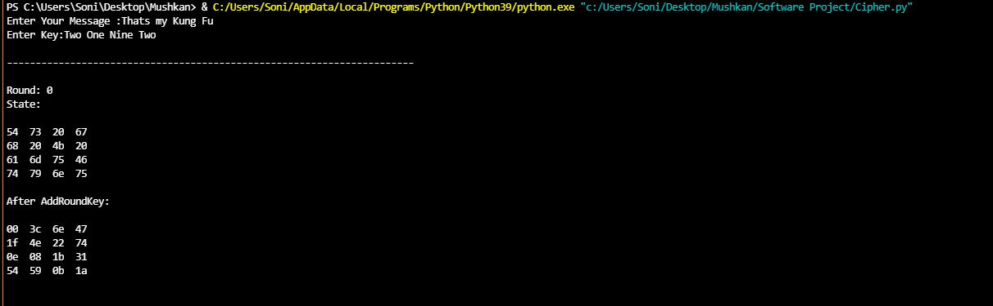

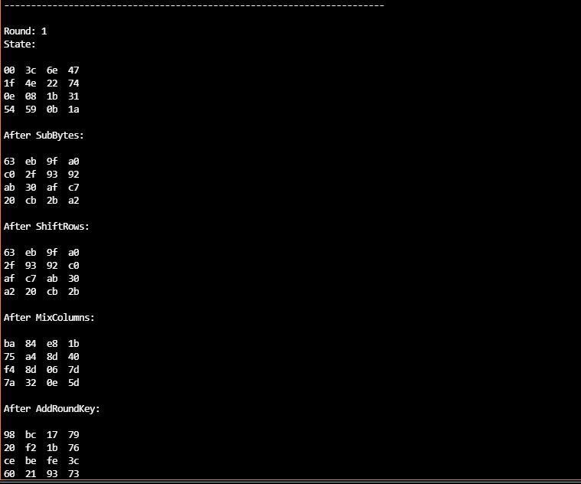

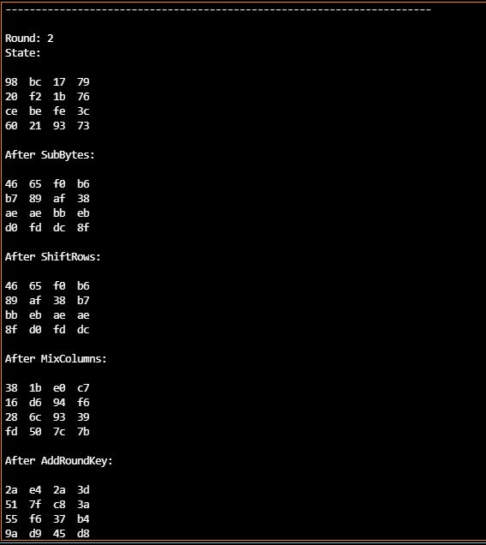

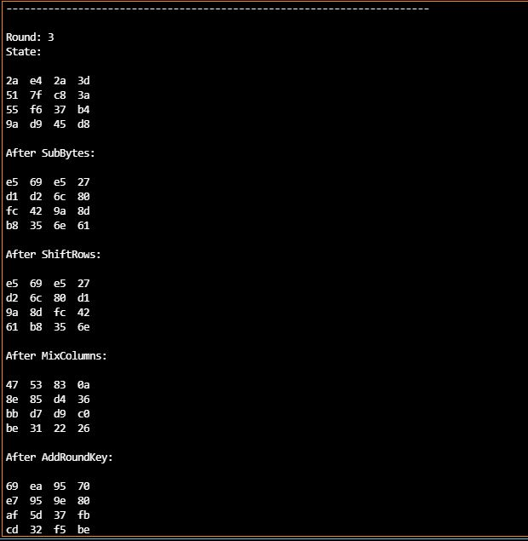

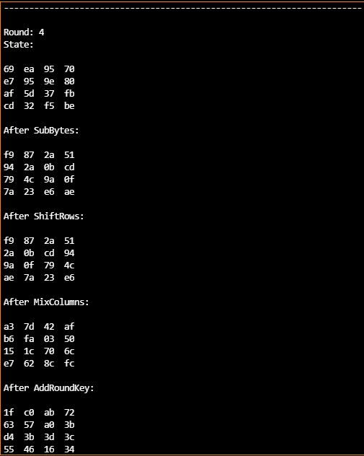

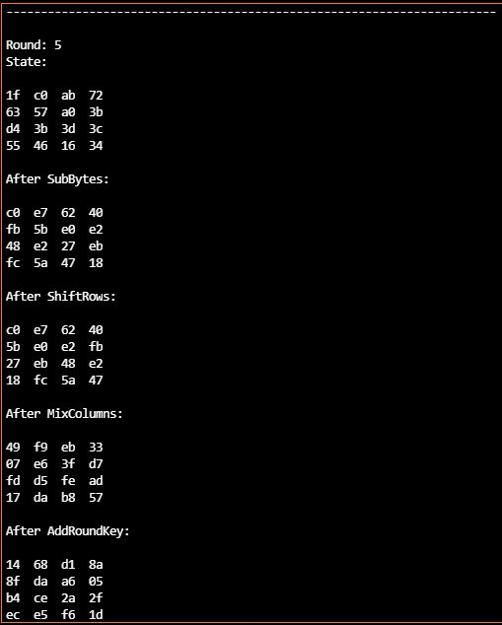

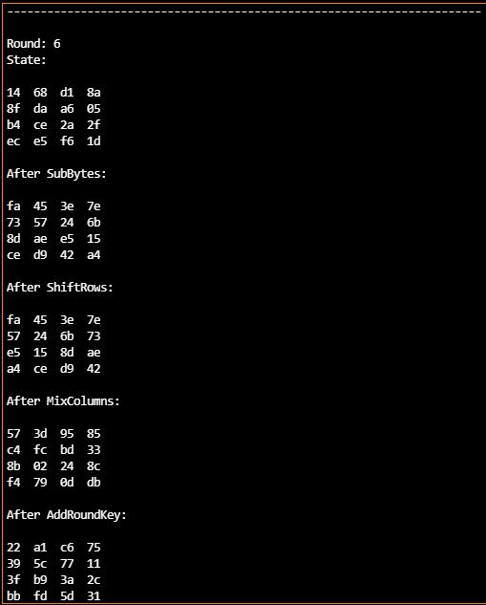

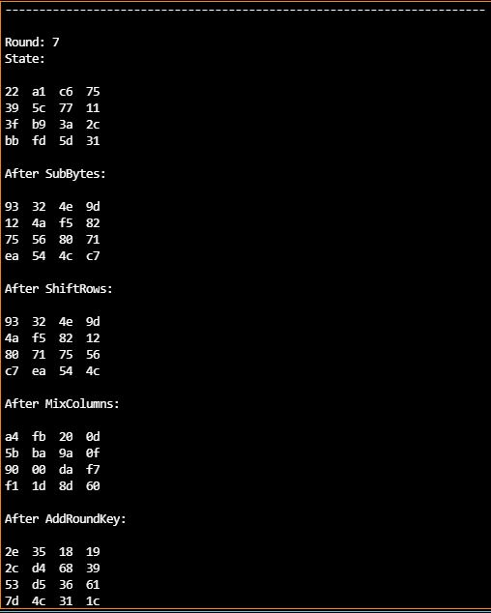

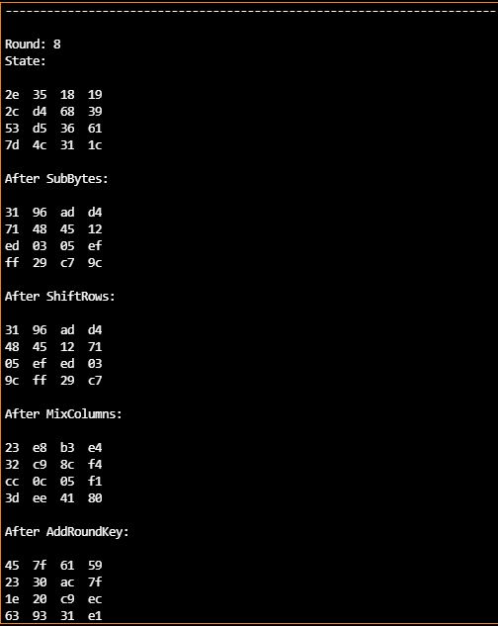

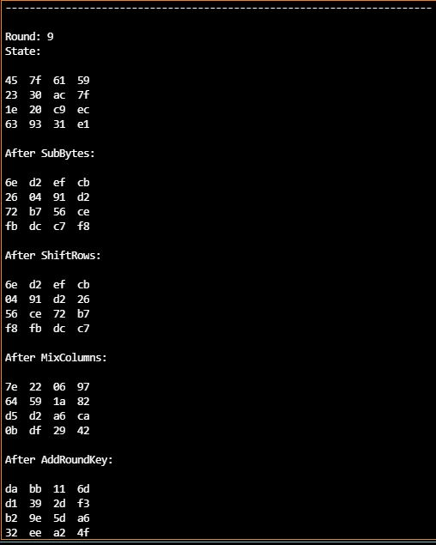
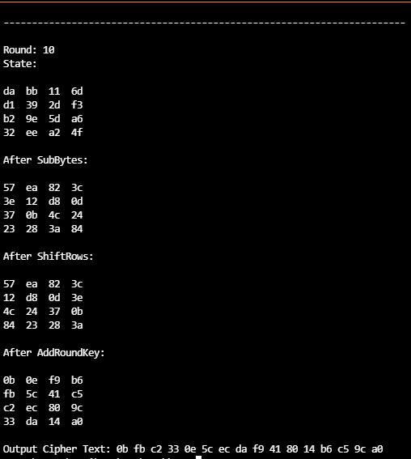

Discussion

The necessary resources such as sixteen S-boxes, inverse S-boxes, multiplicative inverse tables required for the working of customized algorithm were implemented using Python. The key generation and selection protocol have been programmed in Python as well. The acquired tables used with AES framework resulted in text encryption.
However, we were not able to perform decryption as we were getting repeated bugs in our decryption code.

Conclusion

The Advanced Encryption Standard algorithm is an iterative private key symmetric block cipher that can process data blocks of 128 bits through the use of cipher keys with lengths of 128, 192, and 256 bits. An efficient Python implementation of 128-bit block and 128-bit key AES cryptosystem has been presented in this project. An Optimized and Synthesizable Python code is developed for the implementation of both 128-bit data encryption and decryption process & description is verified using Python in Visual Studios Code.

Future Scope

One could work on selection of a larger key size which would make the algorithm is more secure, and a larger input block to increase the throughput. The extra increase in area can however be tolerated. So such an algorithm with high level of security and high throughput can have ideal applications such as in multimedia communications.
Furthermore, study of optimization approaches for the implementations supporting multiple key lengths and modes of operation have tremendous scope for future work.

REFERENCES

- AES page available via http://www.nist.gov/CryptoToolkit.4

- Computer Security Objects Register (CSOR): http://csrc.nist.gov/csor/.

- J. Daemen and V. Rijmen, AES Proposal: Rijndael, AES Algorithm Submission, September 3, 1999, available at [1].
- J. Daemen and V. Rijmen, The block cipher Rijndael, Smart Card research and Applications, LNCS 1820, Springer-Verlag, pp. 288-296.
- B. Gladman’s AES related home page http://fp.gladman.plus.com/cryptography_technology/.
- A. Lee, NIST Special Publication 800-21, Guideline for Implementing Cryptography in the Federal Government, National Institute of Standards and Technology, November 1999.
- A. Menezes, P. van Oorschot, and S. Vanstone, Handbook of Applied Cryptography, CRC Press, New York, 1997, p. 81-83.
- J. Nechvatal, ET. al., Report on the Development of the Advanced Encryption Standard (AES), National Institute of Standards and Technology, October 2, 2000,
- Understanding AES Inverse Mix-Columns Transformation Calculation.pdf
[10] http://www.ijsrd.com/articles/IJSRDV1I9071.pdf

